The Flow of Project Management Software
Project 2010 was designed to help the Project Manager schedule the work of a project and monitor the progress of the project. Some of the high level capabilities of Project 2010 are:
The ability to plan and manage a project using Work Breakdown Structure (outline) format
Work, duration and cost planning, forecasting and tracking
Flexible reporting capabilities and customization
Ability to interface with Project Server and Project Portfolio Servers to allow for integration of projects and resource management within an organization (Professional version only)
Project 2010 allows for both manual and automatic project scheduling
Resource management – planning and forecasting
Budget forecasting and tracking
Baseline and variance reporting
Schedule predictability and what-if scenarios
Dynamic schedule management
Project management software has a flow which reflects the project management process:
Projects are defined and the decision is made to perform the project
More indept planning is conducted to elaborate the tasks, resources and work required to complete the project
Projects will start to be performed
Tracking information of how the working is getting accomplished is feed back to the project manager and updated into the schedule
Stakeholders request changes to the product of the project
Reports are produced to reflect project status and schedule
Steps 4-6 are repeated until the project is completed
When the project is completed a transition will be made to incorporate the product of the project into the businss process.
Reflection is made as to how the project was performed looking for process improvement.
PLACEHOLDER
Project 2010 was developed in two versions of project management software:
Project 2010 Standard is a desktop application and is considered a stand alone schedule management tool. There are capabilities for managing individual projects as well as management of multiple projects with a shared resource pool.
Project 2010 Professional has all of the features of Project 2010 Standard and has the ability to allow publishing of projects to a server environment. This allows for collaboration, communication and resource sharing across projects. A web application is available for on-line project planning, resource updates, and inquiries.
Project Usage
When working with information in Project, you can view data at a high-level or drill down to a detail level. Project offers timescaled views ranging from yearly all the way down to each minute. Schedulers, project managers, and other professionals using this tool will need to determine what level of information is needed to produce the desired output of information. You also need to determine how granular you want to be in maintaining that information.
For example, some organizations manage resource assignments by looking at the week as a whole and ensuring resources have 40 hours of work assigned to them. These organizations do not care if one day shows 6 hours and another day shows 12, they simply look at the total weekly hours. Other organizations drill into the daily view and ensure resources have 8 hours a day.
As you might realize, working with information drilled into the daily view will require you to manage tasks on a daily basis, while working with information on a weekly view only requires you to manage tasks on a weekly basis. This also drives the accuracy of your reports. Management of work on a daily basis gives you accurate reports for each day while management of work on a weekly basis only gives you accurate reports on a weekly basis.
When deciding your usage of project, keep in mind the following:
More Detail = More Work = More Results
Less Detail = Less Work = Less Results
Create a strategy for managing to a specific level of detail and stick with it to be most efficient in Project. For example – do not manage one task on a daily basis and another task on a weekly basis.
What Microsoft Project Will Do for You
Formulate a Strategy
Before a project schedule is created, define what information you are hoping your schedule will return for the work and time you devote to the using the schedule. .
Set your goals for the project schedule:
Define the type of information your project schedule should return?
When performing home remodeling you might be interested in when to schedule the contractors.
When developing a software module you might be interested in estimating work hours of resources and costing.
When performing annual maintenance of machinery you might be interested in the timeline and the number of resources needed to accomplish the project.
Different projects, by nature, require different levels of detail and tracking. Decide what is right for the project you need to accomplish. The more detail the more complex the schedule will become.
What type of metrics (field values ie: work, cost, duration, earned value, etc) will your project management and post-project reporting require?
How will you track your project?
What are your Stakeholders status reporting expectations? Define at the column level.
How much work are you as a project manager willing to do to achieve desired results?
If Project Managers preplan the requirements and the outputs of the project schedule, the schedule will be more productive and result in more valid data.
Project Managers have a tendency to make the project schedule become the project. Preplanning will help project managers avoid this pitfall.
Success Checklist
Checklist to help plan a schedule more effectively:
Goals: Set the output goals of the schedule. Ask yourself: Management of the schedule is useful when I get what type of information from the schedule?
Schedule: Is the schedule a checklist of activities or is it tasks that will be managed? If it is a checklist, should it be an Excel list? If one task is late, should it change the dates for future related tasks?
Reporting: Request details of the content of status reporting required for the project from management. This will help in knowing which pieces of information you will need to focus on during schedule creation and management. It will also help set expectations for stakeholders.
Data: Gather requirements for data reports: by week? by department? by variance to baseline? etc. Some of this information will be standard in Project 2010 and some will be created using customization features.
Tracking: Are tasks required to be tracked by the number of hours worked per task or is tracking by percent complete sufficient? Defining the tracking of the project will be tied to the type of metrics that the project schedule will produce.
Earned Value (EV): if measuring EV is a requirement, more task details, estimating, baseline and tracking details will be required. This will likely result in more work for the project manager. Is help available for managing the project schedule?
Resources: What kind of reporting requirements will resources be responsible for during the project and how will the data be used. Will resource availability be updated collected and updated to the project schedule?
Defining output requirements of the schedule will in turn define the benefits of creating and maintaining the schedule. Establishing these goals will help the project manager focus on the benefits of the schedule for each specific project.
Microsoft Project Usage: More Detail, More Work, More Results, Less Detail, Less Work, Less Results
Lorem ipsum dolor sit amet, consectetur adipiscing elit. Donec id bibendum neque. Mauris nec turpis venenatis dolor varius feugiat non non metus. Suspendisse nisi turpis, aliquet ullamcorper tristique sed, ultricies et lectus. Etiam tempus adipiscing posuere. Sed lectus erat, eleifend eget tempus sed, suscipit et ipsum. Sed non urna tellus, id congue augue. Nulla a justo sem, sed pellentesque metus. Etiam et turpis sit amet eros cursus faucibus. Cum sociis natoque penatibus et magnis dis parturient montes, nascetur ridiculus mus. Vestibulum malesuada metus eu arcu accumsan feugiat blandit ipsum condimentum. Vestibulum diam nisi, faucibus vitae auctor imperdiet, adipiscing id lacus. Nullam sit amet feugiat enim. Nam eget cursus enim. Nam a justo erat, ac tempus nisi. Class aptent taciti sociosqu ad litora torquent per conubia nostra, per inceptos himenaeos.
Cras tincidunt tempus ante eu accumsan. Vivamus porttitor sem tincidunt magna tempus et luctus turpis scelerisque. Donec ornare ante vitae mi pretium ac vestibulum velit vulputate. Integer lacinia fermentum nunc in elementum. Proin rutrum sapien nec ipsum varius euismod. Fusce laoreet tellus purus. Nam ac velit ante, non pharetra eros.
Maecenas arcu velit, accumsan vitae pulvinar nec, tempus ut purus. Proin lobortis, elit in sodales rhoncus, tellus mauris aliquet sem, faucibus tempus ligula erat quis felis. Fusce felis arcu, sollicitudin non vulputate eu, tempus vel sapien. Donec varius nunc non purus mattis scelerisque. Nulla ac viverra dui. Nullam at nibh turpis. Duis sit amet enim metus. Morbi sed sem sit amet lacus tincidunt fringilla. Cras rhoncus eros sit amet velit auctor at semper nunc consequat. Curabitur ac molestie dolor. Mauris dictum leo vitae nunc suscipit vel vulputate magna dictum. Phasellus sagittis, arcu sed rhoncus condimentum, erat nibh scelerisque nisl, a mattis tortor lacus at metus. Donec rhoncus ante purus, et hendrerit arcu. Nullam mollis justo sed justo varius feugiat. Morbi non neque lectus.
Project Desktop 2013 Overview of Versions
Microsoft offers three different versions of Project
Project Standard – This is the base scheduling software product which provides functionality that supports a majority of individuals needing a robust schedule tool. Project Standard also provides the following:
Integration with the Office Store so you can purchase Apps for Project 2013
Integration with SkyDrive for cloud storage of your project plan
Project Professional – The version offers the same features as Project Standard but provides these additional functions:
Ability to inactivate tasks for various business scenarios and to support agile project management
Lync integration (2010 or later) to support team collaboration within Project
Visual resource management using Team Planner view
Ability to integrate with SharePoint 2013/SharePoint Online for storing of project plans and task syncing
Ability to connect to Project Server 2013/Project Online to support an enterprise project and portfolio management system
Project Pro for Office 365 – The version offers the same features as Project Professional but provides these additional functions:
Delivers the software as a subscription service so it is always up to date with updates to the software being applied on a regular basis through Office 365
Provides the ability to stream software to up to 5 devices (e.g. home PC, work PC, and tablet) using a connected Office 365 account
Internet access will be required to have access to all of the functions listed above.
For current pricing and a comparison chart of features, visit www.microsoft.com/project. .
Overview of Project as a Database
Although Project may in some ways looks like Excel, it is actually a very complex database. Below are some reasons to use a database:
Eliminates the need to have information duplicated in multiple locations
Creates a structure of information that can be organized by subject
Creates the ability to have information related to each other
Simplifies the ability the report on related information crossing multiple subjects
If Project was set up like a single file is in Excel, each time you assigned a resource to a task, you would have to duplicate all the details about the resource on every single task. This would create a lot of unnecessary information. In addition, every time a resource detail was changed, this would have to be duplicated on every single task. Duplicate information is a good reason to use a database structure.

(optional screen shot here
By using a database structure within Project, the resource is instead connected to a task but all the details about the resource are stored in another location. This way when a report is needed, details can be pulled from multiple locations. This book is not designed to teach everything that you need to know about databases but please refer to the following chart for an example of how all of this information works together.
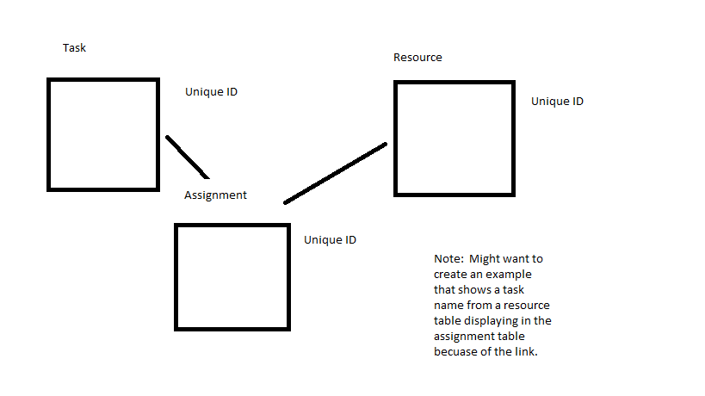
(insert chart here)
Notice that Project has three main tables of information – Task, Resource and Assignment. When a resource is assigned to a task, Project draws a connection/link between a unique resource field with a unique task field. Normally the unique field is not displayed in views, but can be added if desired.
Additional information about this database approach in Project:
All the fields or columns of information are pre-defined when you create a project plan. Creating a plan is simply editing the information in fields/columns.
Hiding a column in Project does not delete the information, it simply removes it from the current view
Inserting a column is simply adding the information to a particular view
Changing a field of information in one view is changing the information in the database and any other view that uses that field will display the change
Some views are designed for a specific purpose and may display task information only, resource information only or some combination of task, resource, and assignment information. For example, the Resource Sheet view does not allow you to display task names in it. That is because it is a specific view to show resource details. If you want to see how those resources are assigned, you should consider another view such as Task Usage, Resource Usage, or Gantt Chart.
This brief discussion should start you on your way to learning more about Project and how its database structure work well when managing schedules.
Review of the Ribbon, Back Stage, Quick Launch
Exploring the Ribbon
The Ribbon is the new Fluent User Interface which you will find across Microsoft Office products. While it might look daunting at first, you will be pleased to know that features formerly hidden in a series of menus and submenus are now easy to find and there are new features available right at your fingertips. The series of tabs located at the top of the Ribbon represent the different sectors of work, such as resource management or task management. Starting with the Task tab, you will see it is divided into logical sections called groups. The group names are listed just below a collection of buttons. Buttons that are larger indicate a feature that is frequently used. Some of the important advantages to the Ribbon include:
Everything is organized on tabs by subject area.
Information on the Format tab automatically responds to the current working environment and provides “view” relevant buttons. Notice the view-specific heading above the Format tab.
The size of the buttons adjust based on your available window or screen size so you don’t lose any capabilities, while maintaining maximum work area screen real estate.
Features are available in a quick one- or two-click fashion.
You can tailor the Ribbon by adding and/or removing features or by adding a new tab.
The File tab is unique and will be addressed in the next section.
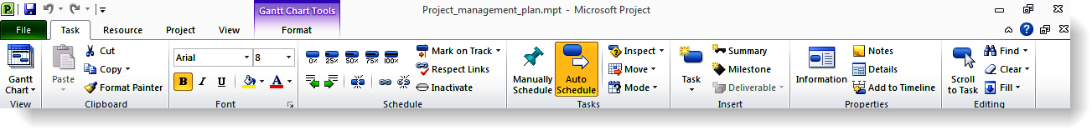
Microsoft Project 2010 Ribbon
The Ribbon can be configured to auto-hide or auto-display giving you valuable screen space as you work on your schedule. To set this, click the “minimize the Ribbon” symbol in the upper right-hand corner of the screen.
Project Ribbon – Expanded
To disable this feature, click the “Expand the Ribbon” symbol in the upper right-hand corner of the screen.
Project Ribbon – Minimized
Backstage View (File Tab)
To centrally locate file management activities, they are located on the File tab. Think of what you “do to the entire file” when you enter this area. This area is now known as the Backstage View. Some of the features available include:
New, open, close, save, and print.
Connect with SharePoint and create PDF/XPS files.
Project Options – aligning options to all new projects or only specific projects.
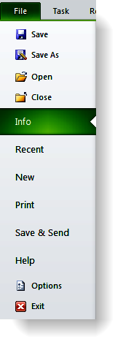
Backstage View (File Tab)
To exit Backstage View either click the File tab again or click the Task tab. Clicking Exit will close Project.
Sample Views and Navigation Stuff
Task Views
Task views are accessed through the Task ribbon and Gantt Chart button located under the Gantt Chart icon. An alternate access point is through the View ribbon. All Gantt Charts contain both the graphic side of the view as well as a table for additional data viewing. All views are available through:
Task ribbon → button under Gantt Chart icon → more views
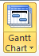
PLACEHOLDER
The following is a summary of the most frequently used Task views:
Gantt Chart – the Gantt Chart is a graphic representation of the start and finish dates for a task. In addition to graphic bars, relationship arrows are also displayed. Gantt Charts will have a data table on the left side of the view called the Task Sheet. The default table of data is included called the Entry table which contains fields designed to aid in the planning and scheduling of tasks. The timescale in the view may be adjusted to show different time density timelines. Below is an example of the Gantt Chart view.
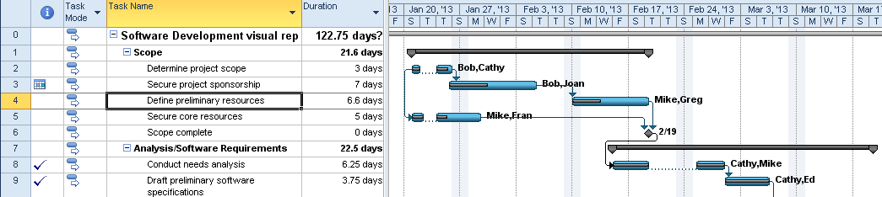
PLACEHOLDER
Tracking Gantt – this view will graphically represent of the start and finish dates of a task like the Gantt Chart above but is designed to help during the tracking phase of the project schedule. Percent complete and comparison of baseline versus actual values and future plan are displayed. In the example below, the beige Gantt bars are the baseline and the blue bars is the running schedule.
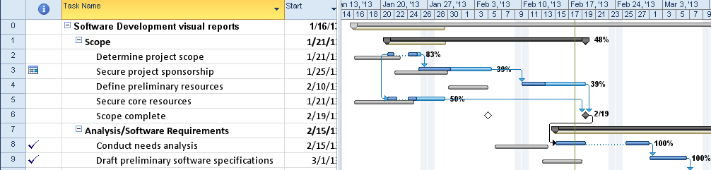
PLACEHOLDER
Network Diagram – The Network diagram is designed as a precedence diagram. It shows the predecessors and successors of tasks without regard to timeframe. When in the Network Diagram view, clicking on Format → Box styles will explain details about the information represented in the Network Diagram. Double clicking on a task will allows access to task information.
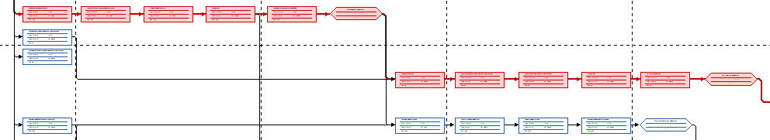
PLACEHOLDER
Calendar view – The calendar view shows the project schedule on a calendar. Date range is available as well as limited customization. Double click on any task name to see more information regarding the tasks. Some customization of the view is available.
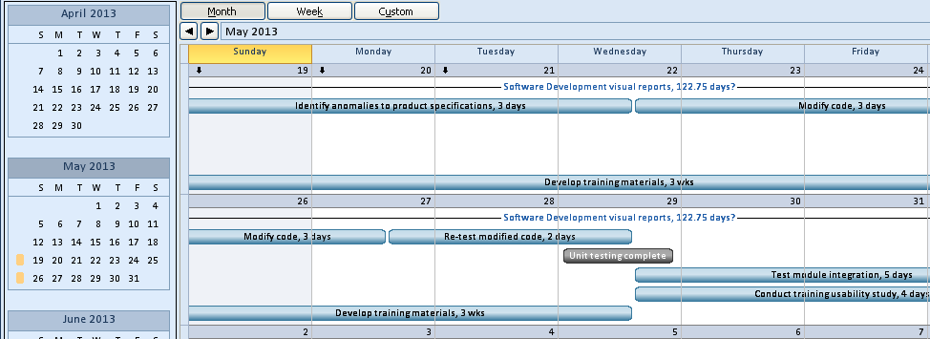
PLACEHOLDER
Task Form – The task form shows information about individual tasks. Right clicking in the view will allow changing to 8 different views for task data such as predecessor and successor, resource work, and resource schedule. The Task Form is a light version of the Detail Task Form which contains more per task data.
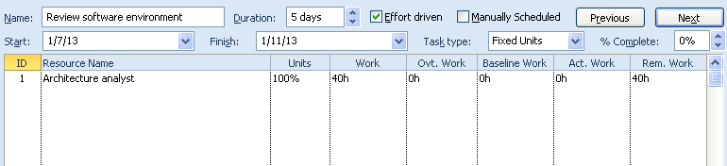
PLACEHOLDER
Task Sheet – The task sheet view looks like an Excel table. It is a table of data which is a subset of the approximately 300 fields of the task section of the database. Tables are typically 6-10 columns of data, organized by topic. Some of the most used tables are: Entry, Work, Duration, and Tracking. To switch to another table view, right click in the box above the task numbers and select another table from the list. Another access point is:
View → Tables
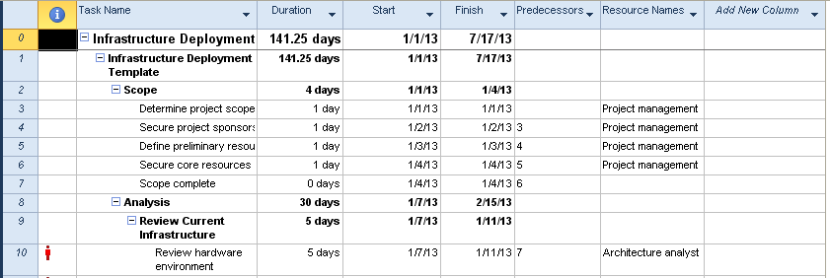
PLACEHOLDER
Timeline View – The Timeline View is a very flexible and customizable view. Tasks may be selected to appear on the timeline to give high level reporting capability. In addition, the timeline has the ability to highlight the timeframe it is representing. The Timeline View may be turned when needed on the from the View → click box to the left of the timeline option. Formatting is available to colorize the view. Comments and milestone markers may also be added. The Timeline view will be discussed in Module 10.
PLACEHOLDER
Task Usage – The Task Usage view shows tasks and the resources assigned to the task. Data in this view comes from the Task and Assignment data sections of the database. By default, the work field of data is shown on the right but additional fields may be added to customize the report and make it more usable. The example below is showing when a task is scheduled and the cost of the resource working on the task by week.
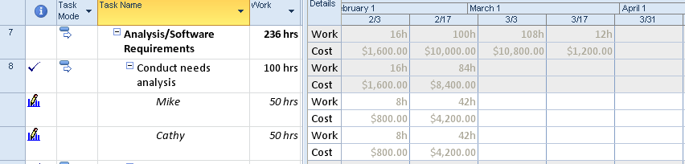
PLACEHOLDER
Resource Views
Resource views are accessed through the Task ribbon and Gantt chart button under the Gantt Chart icon. They can also be accessed from the Resource ribbon by clicking on the words Team Planner button which is the first button on the on the left side of the ribbon. All views are available through:
Task ribbon → button under Gantt Chart icon → More Views
PLACEHOLDER
Resource Sheet – The resource sheet provides the table where resources are added into Project 2010. This table is a subset of the over 300 resource data fields available for resources. The default table is called the Entry table. Other tables are available by right clicking in the in the box above the resource number one and selecting another table. Tables are organized by topic.
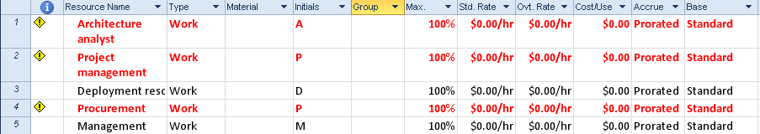
PLACEHOLDER
Resource Form - The Resource Form shows information and assignments for individual resources. Right clicking in the view will allow changing to 5 different views which shows the resource assignment data in different ways. The Resource Form is very useful for viewing resource cost, work and schedule information by resource.
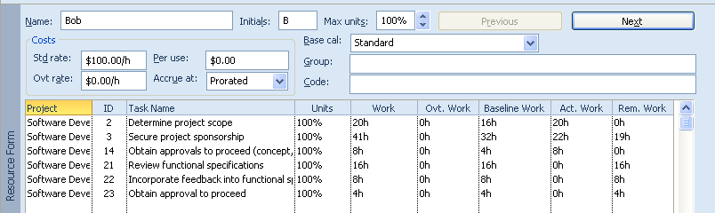
PLACEHOLDER
Resource Graph – The Resource Graph will show work and cost values in graphic format for individual resources. The timeline of the graphic display may be altered to show reports at the time density which is most meaningful for the report. Customization is available to change the graphic layout and data included.
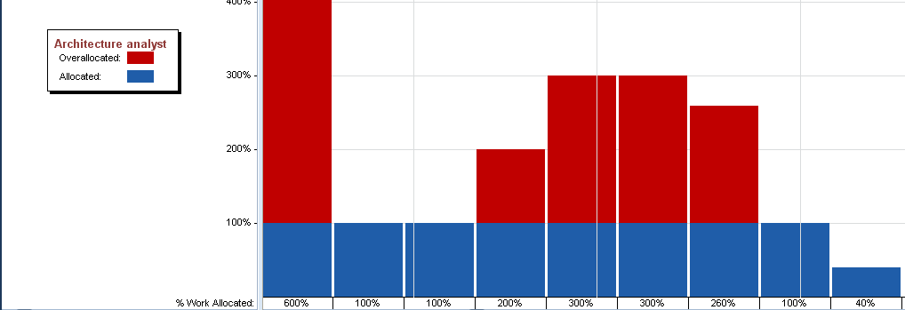
PLACEHOLDER
Team Planner – the Team Planner view is also known as a swim lane view. It will show the work of the resources in timeline format. It will also allow for moving task assignments between resources and to alternate timeframes. This will be a very helpful view for resource leveling and smoothing out work loads. It will also show tasks without assignments. This view is available for Project 2010 Professional only.
PLACEHOLDER
Resource Usage– The Resource Form is a view that shows resources and the tasks assigned to resources. Data in this view comes from the Resource and Assignment data sections of the database. By default the work column is shown on the right side of the screen. In the view below the remaining resource availability has been added.
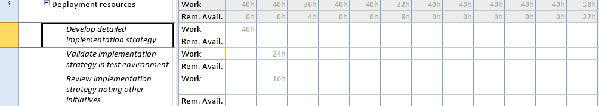
PLACEHOLDER
Zoom Ribbon Section, Insert/Hide Column/Timescale/Scroll to Task
Zooming In and Out
Zooming in or out is the way to adjust the bar chart or time scale portion of a view to show more or less detail. For example, you can display Gantt bars across a daily time scale or across a quarterly time scale.
Two popular methods for zooming in and out are using the Zoom Slider and the Zoom options on the View tab. The Zoom Slider is recommended since that option is always displayed even when you navigate to another view.
You can click the minus and plus buttons to zoom out and zoom in.
You can drag the zoom indicator in between the zoom out and zoom in buttons.
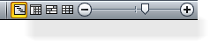
Zoom Slider
Remove or Add a Column
When you hide a column in Project 2010, the column is only removed from view, not deleted from your plan. Keep in mind that hiding a column doesn’t remove any information from your plan.
Hide or Remove a Column
To hide a column from a sheet view:
In a sheet view, select the column you want to hide by clicking its title.
This displays the Gantt Chart Tools tab with the Format tab underneath in the Ribbon.
In the Format tab, Columns group, click Column Settings.
Click Hide Column. You can also press the delete key on your keyboard.
Hide or Remove Column Icons
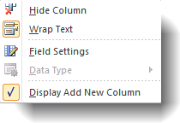
Column Settings Dropdown Menu
Add a Column
To add a new column:
In a sheet view, select the column to the right of where you want to insert the column.
This displays the Gantt Chart Tools tab with the Format tab underneath in the Ribbon.
In the Format tab, Columns group, click Insert Column.
A new blank column is displayed to the left of the column that you had selected. Click the dropdown arrow in the title box to specify the type of information from the list of possible column types (or fields) that the column will contain.
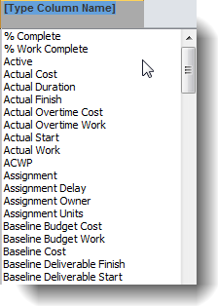
Add New Column
Also at the end of every table in a Sheet view (the far right) there is an Add New Column option available.
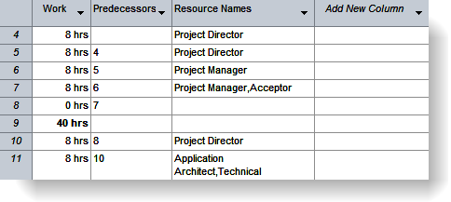
Add New Column in View
To unhide a previously hidden column, insert the column as you would with any new column.
Using the Scroll to Task Button
Using the Scroll to Task button re-centers the bar chart on the date where a selected task occurs.
To use this feature, complete the following steps:
In the Entry table, select the task you want to have displayed in the bar chart.
On the Task tab, Editing group, click the Scroll to Task button.
Scroll to Task Icon
Project displays the date or dates where the selected task occurs on the bar chart.
Conversely, you can view the name of a task in the Entry table by clicking on its bar in the bar chart. Project will highlight the corresponding task in the Entry table.
Go To and Find
Lorem ipsum dolor sit amet, consectetur adipiscing elit. Donec id bibendum neque. Mauris nec turpis venenatis dolor varius feugiat non non metus. Suspendisse nisi turpis, aliquet ullamcorper tristique sed, ultricies et lectus. Etiam tempus adipiscing posuere. Sed lectus erat, eleifend eget tempus sed, suscipit et ipsum. Sed non urna tellus, id congue augue. Nulla a justo sem, sed pellentesque metus. Etiam et turpis sit amet eros cursus faucibus. Cum sociis natoque penatibus et magnis dis parturient montes, nascetur ridiculus mus. Vestibulum malesuada metus eu arcu accumsan feugiat blandit ipsum condimentum. Vestibulum diam nisi, faucibus vitae auctor imperdiet, adipiscing id lacus. Nullam sit amet feugiat enim. Nam eget cursus enim. Nam a justo erat, ac tempus nisi. Class aptent taciti sociosqu ad litora torquent per conubia nostra, per inceptos himenaeos.
Cras tincidunt tempus ante eu accumsan. Vivamus porttitor sem tincidunt magna tempus et luctus turpis scelerisque. Donec ornare ante vitae mi pretium ac vestibulum velit vulputate. Integer lacinia fermentum nunc in elementum. Proin rutrum sapien nec ipsum varius euismod. Fusce laoreet tellus purus. Nam ac velit ante, non pharetra eros.
Help
Lorem ipsum dolor sit amet, consectetur adipiscing elit. Donec id bibendum neque. Mauris nec turpis venenatis dolor varius feugiat non non metus. Suspendisse nisi turpis, aliquet ullamcorper tristique sed, ultricies et lectus. Etiam tempus adipiscing posuere. Sed lectus erat, eleifend eget tempus sed, suscipit et ipsum. Sed non urna tellus, id congue augue. Nulla a justo sem, sed pellentesque metus. Etiam et turpis sit amet eros cursus faucibus. Cum sociis natoque penatibus et magnis dis parturient montes, nascetur ridiculus mus. Vestibulum malesuada metus eu arcu accumsan feugiat blandit ipsum condimentum. Vestibulum diam nisi, faucibus vitae auctor imperdiet, adipiscing id lacus. Nullam sit amet feugiat enim. Nam eget cursus enim. Nam a justo erat, ac tempus nisi. Class aptent taciti sociosqu ad litora torquent per conubia nostra, per inceptos himenaeos.
Cras tincidunt tempus ante eu accumsan. Vivamus porttitor sem tincidunt magna tempus et luctus turpis scelerisque. Donec ornare ante vitae mi pretium ac vestibulum velit vulputate. Integer lacinia fermentum nunc in elementum. Proin rutrum sapien nec ipsum varius euismod. Fusce laoreet tellus purus. Nam ac velit ante, non pharetra eros.
Maecenas arcu velit, accumsan vitae pulvinar nec, tempus ut purus. Proin lobortis, elit in sodales rhoncus, tellus mauris aliquet sem, faucibus tempus ligula erat quis felis. Fusce felis arcu, sollicitudin non vulputate eu, tempus vel sapien. Donec varius nunc non purus mattis scelerisque. Nulla ac viverra dui. Nullam at nibh turpis. Duis sit amet enim metus. Morbi sed sem sit amet lacus tincidunt fringilla. Cras rhoncus eros sit amet velit auctor at semper nunc consequat. Curabitur ac molestie dolor. Mauris dictum leo vitae nunc suscipit vel vulputate magna dictum. Phasellus sagittis, arcu sed rhoncus condimentum, erat nibh scelerisque nisl, a mattis tortor lacus at metus. Donec rhoncus ante purus, et hendrerit arcu. Nullam mollis justo sed justo varius feugiat. Morbi non neque lectus.
Duis blandit tellus at sem bibendum eu facilisis augue sodales. Pellentesque tincidunt sem at tellus lobortis volutpat. Cum sociis natoque penatibus et magnis dis parturient montes, nascetur ridiculus mus. Suspendisse at lorem non turpis bibendum egestas at eget urna. Duis ullamcorper luctus libero a sagittis. Proin at tellus nec neque eleifend pharetra. Maecenas sed dignissim felis. Aenean eu magna risus. Praesent turpis lorem, laoreet a aliquam quis, dignissim quis dolor. Quisque laoreet, nisl euismod tincidunt accumsan, libero velit volutpat mauris, sit amet semper tortor mauris at velit. Suspendisse rutrum tincidunt magna vitae mattis. Aliquam vestibulum mi in justo congue dignissim. Lorem ipsum dolor sit amet, consectetur adipiscing elit. Suspendisse euismod ipsum at est ullamcorper sit amet dignissim quam iaculis.
Donec ultrices dolor vitae lorem luctus vel imperdiet eros venenatis. Aliquam hendrerit tincidunt nisl, quis cursus nisi vehicula ac. Suspendisse accumsan mattis enim, at sodales magna commodo eu. Morbi consequat dignissim felis, vitae sodales ipsum vulputate mollis. Aenean leo elit, vehicula semper laoreet quis, ultrices ut libero. Donec neque dui, cursus at fringilla non, pharetra sed turpis. Phasellus iaculis pretium lacus ut sollicitudin. Mauris erat orci, placerat non luctus rutrum, sodales eu arcu. Donec metus erat, eleifend non vestibulum sed, scelerisque at elit. Duis pretium luctus varius. Nunc congue, sapien in congue dictum, massa nibh tincidunt neque, ac porttitor leo neque non ligula. Vestibulum nec lectus metus, mattis dapibus mi. Quisque bibendum, risus quis imperdiet scelerisque, mauris felis luctus neque, in iaculis ante diam nec libero. Aliquam eu dui magna.
Keyboard Shortcuts
Key Tips allow you to use your keyboard to navigate through the Quick Access Toolbar and the Ribbon. To turn on Key Tips, simply tap the Alt key. You can also press F10 twice. Follow the letters and numbers that are displayed to use the function you desire.
You can also use keyboard shortcuts to navigate through your project. The following table lists keys that are useful when navigating within views and windows.
Key Tips and Keyboard Shortcuts
Key Tips & Shortcut | Outcome
Tab | Move right one field in an Entry table or dialog box.
Shift+Tab | Moves left one field in an Entry table or dialog box.
Home | Moves to the beginning of a row or field of information.
End | Moves to the end of a row or field of information.
Page Up | Moves up one screen.
Page Down | Moves down one screen.
Alt + Page Up / Alt + Page Down | Moves left or right one screen on the time scale.
Alt + ⇦ / Alt + ⇨ | Moves the time scale one unit left or right (as defined by the bottom time scale tier).
Alt + Home | Moves to the project start date in the bar chart.
Alt + End | Moves to the project finish date in the bar chart.
Ctrl + Home | Moves to the first field in the first row of the Entry table or the same location in any other sheet view.
Ctrl + End, Home | Moves to the first field in the last row of the Entry table or the same location in any other sheet view.
Ctrl +  | Moves to the First Row.
Ctrl +  | Moves to the Last Row.
F1 | Turns on Project Help.
F2 | Activates in-cell editing for the selected field.
F3 | Displays all tasks or resources when a prior filter was applied.
F5 | Goes to a specific row ID number or a date on the time scale.
F6 | Activates the other pane in a combination or dual-pane view.
F10 | Press twice to turns on Key Tips. You can also tap the Alt key.
Ctrl + Shift + F5 | Displays the Gantt bar for the selected task.
Ctrl + F4 | Closes the Project window.
Ctrl + F5 | Changes the Gantt Chart view from maximized to previous size (i.e., view window is separated from Project window).
Ctrl + F10 | Maximizes the Gantt Chart view and combines it with the Project window.
Ctrl + F9 | Allows you to turn on and off Auto Calculate.
Ctrl + F6 | Displays the next open Project window.
Ctrl + Shift + F6 | Displays the previous open Project window.
Alt + Spacebar / Alt + Hyphen | Displays the application control menu.
Insert | When the Task ID is selected, a new blank row is added in the Entry table.
Delete | When the Task ID is selected, a row is deleted from the Entry table.
Alt + F3 | Displays the Field Settings dialog box for the active column.
Alt + F4 | Closes Project.
Shift + F2 | Displays Task Information in Gantt Chart view. Displays Resource Information in Resource Sheet view.
Shift + F3 | Sorts by ID number.
Shift + F6 | Enables the horizontal and vertical split bars in Gantt Chart view.
Shift + F11 / Alt + Shift + F1 | Creates a new version of your schedule (e.g., Project: 2).

